Core Missings
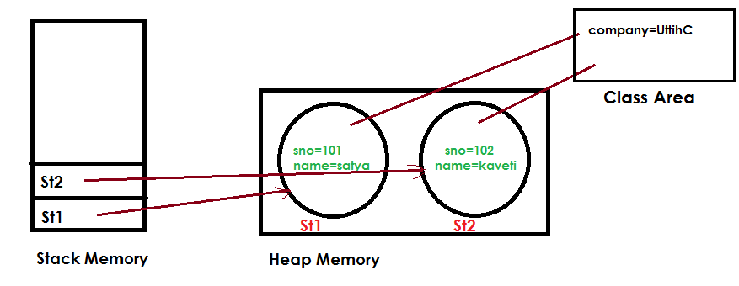
Static variable will get the memory only once, if any object changes the value of the static variable, it will retain its value

Declaring Multiple Variables
int i1, i2, i3 = 0;
As you should expect, three variables were declared: i1, i2, and i3. However, only one of those values was initialized: i3. The other two remain declared but not yet initialized.

int num, String value; // DOES NOT COMPILE
This code doesn’t compile because it tries to declare multiple variables of different types in the same statement.

8. public boolean equals(Object obj)
Used to make equal comparison between two objects.it has 2 versions while comparing Objects
1.equals () at Object comparision level
- If we are comparing non-String Objects eqauls() method it comapiars refrences of Objects.
- It is same as “== “ Operator

2. equals() at String Comparision Level
- If we are comparing String data on .eqauls() method comapiars only content.
- References are doesn’t matter.
But == always compairs references
.

Protected Object clone() throws CloneNotSupportedException
Creates and returns the exact copy (clone) of the object.
Rules
- To clone an Object it must implement java.lang.Clonable Interface
- Otherwise it will return CloneNotSupportedException.
Public class Student implements Cloneable {
int sno;
String name;
public Student(int sno, String name) {
this.sno = sno;
this.name = name;
}

public static void main(String[] args) throws CloneNotSupportedException {
Student s1 = new Student(101, “Satya”);
Student s2 = (Student) s1.clone();
System.out.println(“S1 data “+s1.sno+”:”+s1.name);
System.out.println(“S2 data “+s2.sno+”:”+s2.name);
}
}
S1 data 101:Satya
S2 data 101:Satya

We have two types of Cloning in java
- Shallow Cloning
- Deeply Cloning

Shallow copy Cloning
- The default version of clone() method creates the shallow copy of an object.
- The shallow copy of an object will have exact copy of all the fields of original object.
- If original object has any references to other objects as fields, then only references of those objects are copied into clone object, copy of those objects are not created
- Any changes made to those objects through clone object will be reflected in original object or vice-versa.
- Shallow copy is not 100% independent of original object.
Example
package clone;
class Address {
String dno;
String city;
public Address(String dno, String city) {
super();
this.dno = dno;
this.city = city;
}
}

class Student implements Cloneable {
int sno;
String name;
Address address;
public Student(int sno, String name, Address address) {
super();
this.sno = sno;
this.name = name;
this.address = address;
}
@Override
protected Object clone() throws CloneNotSupportedException {
return super.clone();
}
}

public class ShallowClone {
public static void main(String[] args) throws CloneNotSupportedException {

Address addr = new Address(“3-100”, “HYDERABAD”);
Student s1 = new Student(101, “Satya”, addr);
Student s2 = (Student) s1.clone();
System.out.println(s1.address.city+” : “+s2.address.city); //HYDERABAD : HYDERABAD

s1.address.city = “KANURU”; //Changing the Value

System.out.println(s1.address.city+” : “+s2.address.city);//KANURU : KANURU

//S1,S2 are dependent to each other, sharing same Object reference

}
}

Deeply copy Cloning
- To create the deep copy of an object, you have to override clone() method
- Deep copy of an object will have exact copy of all the fields of original object just like shallow copy.
- But in additional, if original object has any references to other objects as fields, then copy of those objects are also created by calling clone() method on them.
- That means clone object and original object will be 100% disjoint. They will be 100% independent of each other
- Changes won’t reflect each other.
Example
package clone.deep;
class Address implements Cloneable{
String dno;
String city;
public Address(String dno, String city) {
super();
this.dno = dno;
this.city = city;
}
@Override
protected Object clone() throws CloneNotSupportedException {
// TODO Auto-generated method stub
return super.clone();
}
}

class Student implements Cloneable {
int sno;
String name;
Address address;

public Student(int sno, String name, Address address) {
super();
this.sno = sno;
this.name = name;
this.address = address;
}

@Override
protected Object clone() throws CloneNotSupportedException {
Student student = (Student) super.clone();
student.address = (Address) address.clone();
return student;
}

}

public class DeeplyClone {
public static void main(String[] args) throws CloneNotSupportedException {

Address addr = new Address(“3-100”, “HYDERABAD”);
Student s1 = new Student(101, “Satya”, addr);
Student s2 = (Student) s1.clone();

System.out.println(s1.address.city+” : “+s2.address.city); //HYDERABAD : HYDERABAD

s1.address.city = “KANURU”; //Changing the Value

System.out.println(s1.address.city+” : “+s2.address.city);//KANURU : KANURU

//S1,S2 are dependent to each other , sharing same Object reference

}
}
HYDERABAD : HYDERABAD
KANURU : HYDERABAD

The shallow copying of this object will be pointing to the same memory reference as the original object. So a change in myData by either original or cloned object will be reflected in other also.
But in deep copying there will memory allocated and values assigned to the property will be same. Any change in object will not be reflected in other
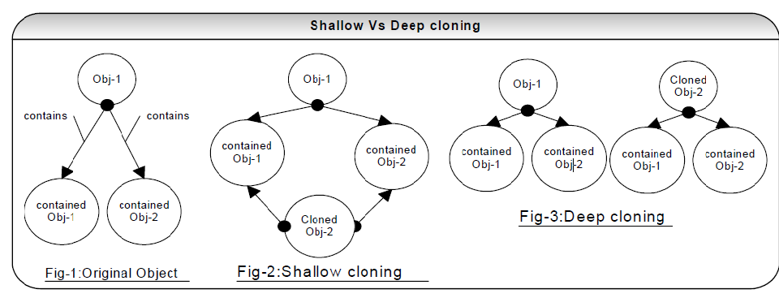

Java Reflection API (java.lang.Class)
Reflection is commonly used by programs which require the ability to examine or modify the runtime behavior of applications running in the Java virtual machine
Where it is used
- IDE (Integrated Development Environment) e.g. Eclipse, MyEclipse, NetBeans etc.
- Debugger
- Test Tools etc

1. Java.lang.Class
The java.lang.Class class performs mainly two tasks:
- Provides methods to get the metadata of a class at run time.
- Provides methods to examine and change the run time behavior of a class.

2. Methods
Method | Description
public String getName() | returns the class name
public static Class forName(String className)throws ClassNotFoundException | Loads the class and returns the reference of Class class.
public Object newInstance()throws InstantiationException,IllegalAccessException | Creates new instance.
public boolean isInterface() | Checks if it is interface.
public boolean isArray() | Checks if it is array.
public boolean isPrimitive() | Checks if it is primitive.
public Class getSuperclass() | Returns the superclass class reference.
public Field[] getDeclaredFields() | Returns the total number of fields of this class.
public Method[] getDeclaredMethods() | Returns the total number of methods of this class.
public Constructor[] getDeclaredConstructors() | Returns the total number of constructors of this class.
public Method getDeclaredMethod(String name,Class[] parameterTypes)throws NoSuchMethodException,SecurityException | Returns the method class instance.

Difference between final, finally and finalize
No. | final | finally | finalize
1) | Final is used to apply restrictions on class, method and variable. Final class can't be inherited, final method can't be overridden and final variable value can't be changed. | Finally is used to place important code, it will be executed whether exception is handled or not. | Finalize is used to perform clean up processing just before object is garbage collected.
2) | Final is a keyword. | Finally is a block. | Finalize is a method.

V. Java UI (Applets/Swings)
In JAVA we write two types of programs or applications. They are standalone applications (Local/Desktop) and distributed applications (web/Network)
Initially, before Servlets come into picture above 2 types of applications are implemented using
- Swings Developing Standalone Applications
- Applets Developing Distributed Applications

Applet Basics
“An applet is a JAVA program which runs in the context of browser or World Wide Web”.
- To deal with applets we must import a package called java.applet.*. This package
- It only one class Applet whose fully qualified name is java.applet.Applet.

In java.applet.Applet we have four life cycle methods. They are public void init (), public void start (), public void stop (), public void destroy (), void paint () it not a life cycle method

- Public void init ():
This is the method which is called by the browser only one time after loading the applet. In this method we write some block of statements which will perform one time operations, such as, obtaining the resources like opening the files, obtaining the database connection, initializing the parameters, etc.
- Public void start ():
Start method will be called each and every time. In this method we write the block of statement which provides business logic.
- Public void stop ():
Stop method is called by the browser when we minimize the window. In this method we write the block of statements which will temporarily releases the resources which are obtained in init method.

- Public void destroy ():
This is the method which will be called by the browser when we close the window button or when we terminate the applet application. In this method we write same block of statements which will releases the resources permanently which are obtained in init method.

- Public void paint ().
This is the method which will be called by the browser after completion of start method. This method is used for displaying the data on to the browser. Paint method is internally call drawstring method

STEPS for developing APPLET Program
- Import java.applet.Applet package.
- Choose the user defined public class that must extends java.applet.Applet class
- Overwrite the life cycle methods of the applet if require.
- Save the program and compile.
- Run the applet: To run the applet we have two ways.
- Using HTML program
- Using applet viewer tool.
public class AppletDemo extends Applet {
String s = "";

public void init() {
s = s + " -INIT";
}
public void start() {
s = s + " -START";
}
public void paint(Graphics g) {
g.drawString(s, 50, 50);
}

public void stop() {
s = s + " -STOP";
}

public void destroy() {
s = s + " -DESTROY";
}
}

Compile the above Program, Run using any of below methods
1) Using HTML program
<APPLET code="AppletDemo " height=100 width=150>

2) Using applet viewer tool.
appletviewer AppletDemo.java

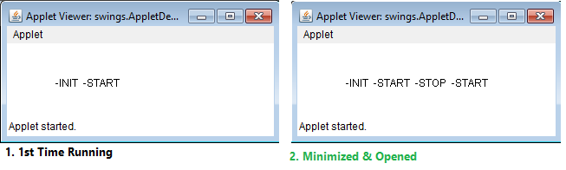

Swing Basics
We can develop standalone applications by using AWT (old) & Swing concepts
For developing any Swing based application we need to extend either java.awt.Frame or javax.swing.JFrame
Difference between AWT and Swing
No. | Java AWT | Java Swing
1) | AWT components are platform-dependent. | Java swing components are platform-independent.
2) | AWT components are heavyweight. | Swing components are lightweight.
3) | AWT doesn't support pluggable look and feel. | Swing supports pluggable look and feel.
4) | AWT provides less components than Swing. | Swing provides more powerful components such as tables, lists, scrollpanes, colorchooser, tabbedpane etc.
5) | AWT doesn't follows MVC | Swing follows MVC.
public class FrameDemo extends Frame {
public FrameDemo() {
setTitle("Demo");
setSize(100, 100);
setBackground(Color.black);
setForeground(Color.red);
setVisible(true);
}

public static void main(String[] args) {
new FrameDemo();
}
}
 This is very basic program. We will explain the in detail in upcoming topics

AWT (abstract windowing toolkit)
See, java.awt.* & javax.swing.* both packages hierarchy almost same. Only difference is letter ‘J’
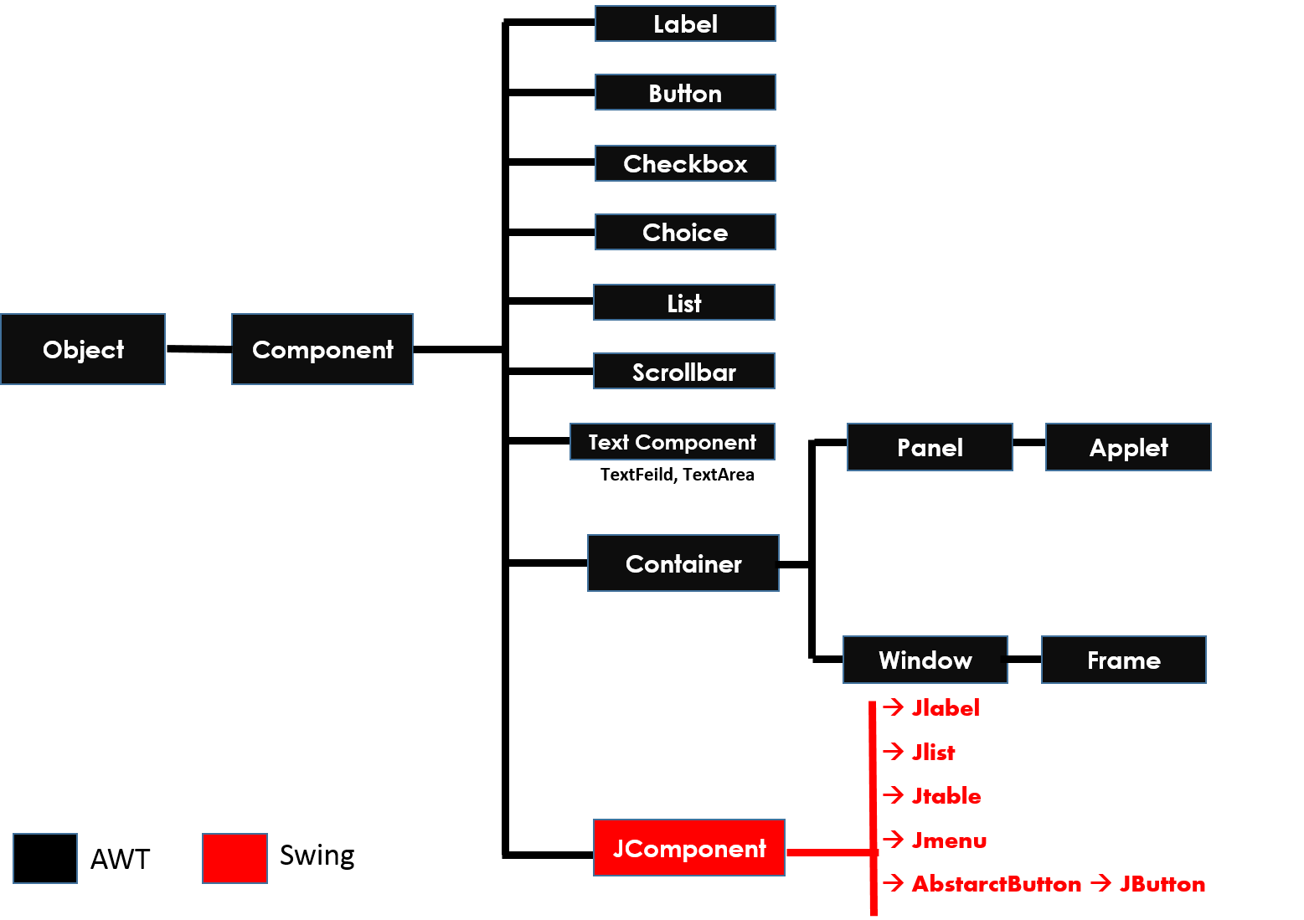
1. Component:
Component is any GUI Component like Label, Button, Etc
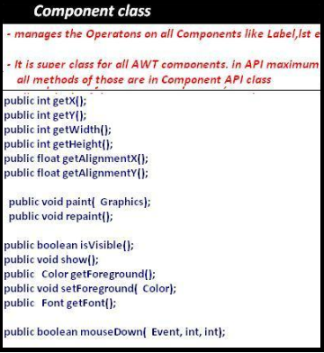
2. Container
Container is an empty space, we have to place components
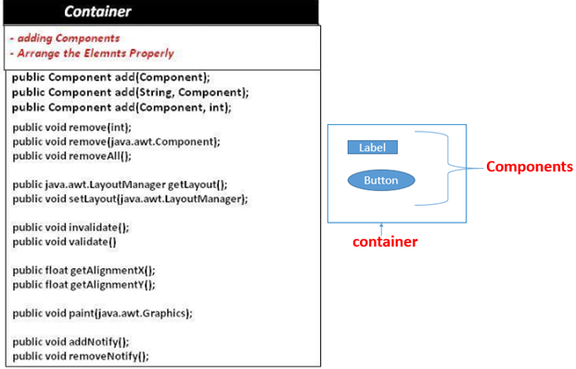
- Window & Frame
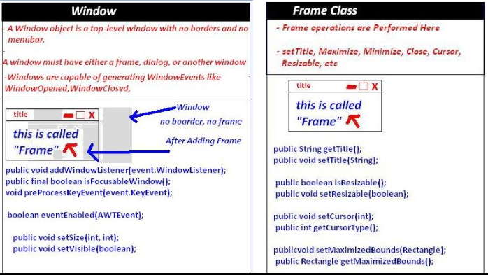

- Panel & Applet
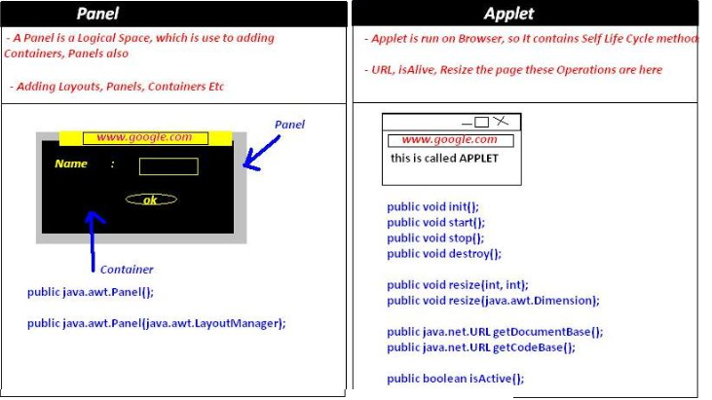

4. Events Handling
As a part of GUI applications we use to create two types of components. They are passive components and active components
- Passive component, no interaction from the user. For example Label.
- Active component there is an interaction from the user. For example button, check box, etc

For developing Event handling, a class must have below steps
- Class which implement Listener Interface
- Component must register with Listener
- Get the object of Event class
- Implement event method
1. Class which implement Listener Interface
Every interactive component must have a predefined listener whose general notation is xxx listener.
Button | java.awt.event.ActionListener
Choice | java.awt.event.ItemListener
TextField | java.awt.event.TextListener
TextArea | java.awt.event.TextListener
Scrollbar | java.awt.event.AdjustmentListener

2 .Component must register with Listener
Each and every interactive component must be registered and unregistered with particular event and Listener. The general form of registration and un-registration methods is as follows:
public void addxxxListener (xxxListener);
public void removexxxListener (xxxListener);
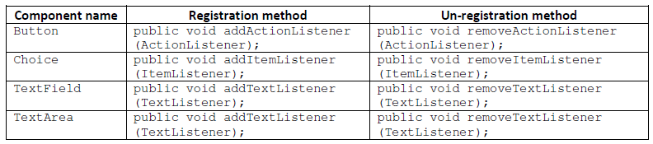
3. Get the object of Event class
Whenever we interact any active component, the corresponding active component Event class object will be created. That object contains two details:
1. Name of the component.
2. Reference of the component.
The general form of every Event class is xxxEvent.
Component name | Event name
Button | java.awt.event.ActionEvent
choice | java.awt.event.ItemEvent
textField | java.awt.event.TextEvent
textArea | java.awt.event.TextEvent
scrollbar | java.awt.event.AdjustmentEvent

4. Implement Event method
All these methods are present in xxxLisnter classes. We have to implement appropriate method
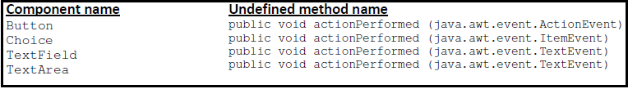

5. Components
1. Label
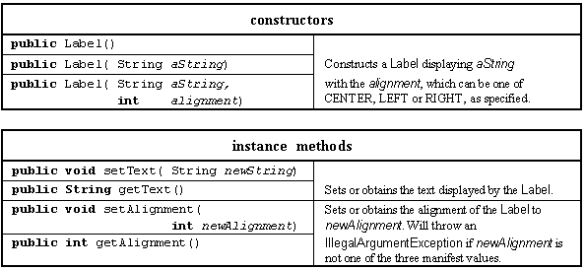
2. Button
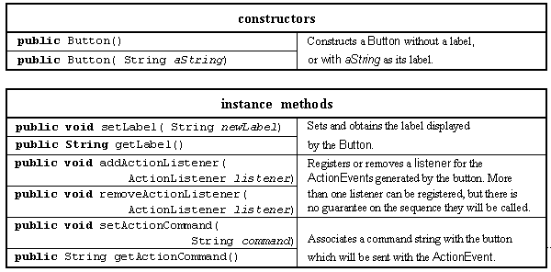

3.TextComponet
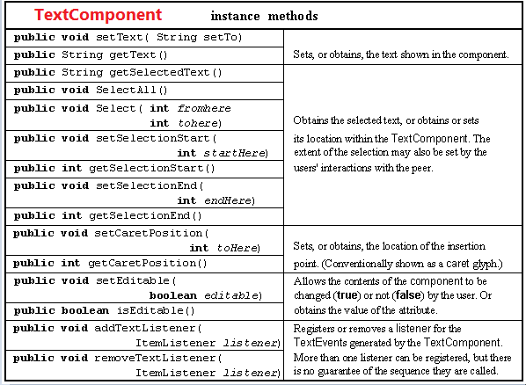

4. TextField
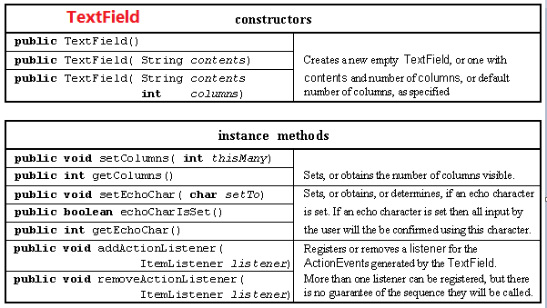
- Layout Managers
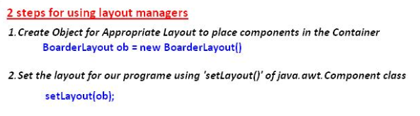
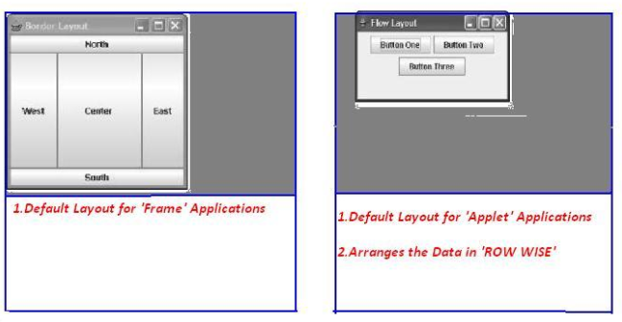
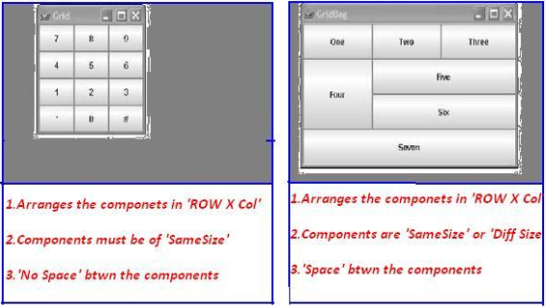
Steps for developing awt program:
1. Import the appropriate packages.
2. Choose the appropriate class and it must extend java.awt.Frame and implements appropriate Listener if required.
3. Identify & declare components as data members in the top of the class.
4. Set the title for the window.
5. Set the size of the window.
6. Create Objects of the components in the Constructor which are identified in step 3.
7. Add the created components to container.
8. Register the events of the appropriate interactive component with appropriate Listener.
9. Make the components to be visible (setvisible(true)).
10. Define the undefined methods in the current class which is coming from appropriate Listener.
11. Write functionality to GUI component in that method

Example
public class LoginDemo extends Frame implements ActionListener {
// 1. Decalring components
Label l1, l2, status;
TextField t1, t2;
Button login;

public LoginDemo() {
// 4,5 Setting title & Size
setSize(200, 200);
setTitle("Login");

// 6.creating Component Objects
l1 = new Label("Username : ");
l2 = new Label("Password : ");
status = new Label("Status");
t1 = new TextField(50);
t2 = new TextField(50);
login = new Button("Login");

// 7.adding componets to container
add(l1);
add(t1);
add(l2);
add(t2);
add(login);
add(status);
setLayout(new FlowLayout());

// 8.reister with Listener
login.addActionListener(this);
setVisible(true);// 9.setvisble
}

@Override // 10
public void actionPerformed(ActionEvent e) {
if (e.getSource() == login) {
// 11.implemeting Logic
status.setText(t1.getText() + " : " + t2.getText());
}
}

public static void main(String[] args) {
new LoginDemo();
}
}
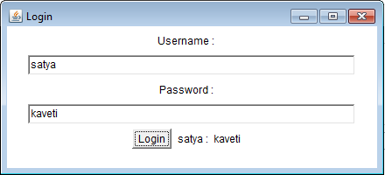
Similarly we have no.of components but the process of each one is similar.

Combined steps to develop FRAME and APPLET applications
1. Import appropriate packages for GUI components (java.awt.*) providing functionality to GUI components (java.awt.event.*) and for applet development (java.applet.Applet).
2. Every user defined class must extend either Frame or Applet and it must implement appropriate Listener if required.
3. Identify which components are required to develop a GUI application.
4. Use life cycle methods (init, start, destroy) in the case of applet, use default Constructor in the case of Frame for creating the components, adding the components, registering the components, etc.
5. Set the title of the window.
6. Set the size of the window.
7. Set the layout if required.
8. Create those components which are identified.
9. Add the created components to container.
10. Every interactive component must be registered with appropriate Listener.
11. Make the components to be visible in the case of Frame only.
12. Implement or define the abstract method which is coming from appropriate Listener.

9.3.5 Cursors - Enumeration VS Iterator VS ListIterator
ListIterator is subclass of List.so all the methods are available in ListIterator.
We have to follow 3 steps to use Cursors in our application
- Get the all elements in a collection in Cursor Object
- Check is next/previous element is exist or not
- Get the element
Enumeration (vector/stack) | Iterator(ArrayList) | ListIterator (LinkedList)
Can iterate over an Collection  Remove operation not allowed  Add operation not allowed  Backward direction not allowed  1.Public Enumeration elements()  Ex. Enumeration = v.elemetnts()  2.Boolean hasMoreElements()  3.E nextElement() | Can iterate over an Collection  Remove operation allowed  Add operation not allowed  Backward direction not allowed  1.Public Iterator iterator()  Ex. Iterator = l.iterator()  2.Boolean hasNext()  3.E next()  void remove() | Can iterate over an Collection  Remove operation allowed  Add operation allowed  Backward direction allowed  1.Public ListIterator listIterator()  Ex. ListIterator = l.listIterator ()  add(E e)  hasPrevious()  nextIndex()  previous()  previousIndex()  remove()  hasNext()  next()  set(E e)

Enumeration Example using Vector  public class VectorEnumation {  public static void main(String[] args) {  Vector v = new Vector();  for (int i = 1; i <= 10; i++) {  v.addElement(i);  }  Enumeration e = v.elements();  while (e.hasMoreElements()) {  Object s = (Object) e.nextElement();  System.out.print(s + ",");  }  }  }  1,2,3,4,5,6,7,8,9,10, | Iterator Example using ArrayList  public class ArrayListIterator {  public static void main(String[] a) {  ArrayList l = new ArrayList<>();  l.add("A");  l.add(10);  l.add("A");  l.add(null);  Iterator i= l.iterator();  while (i.hasNext()) {  Object s = (Object) i.next();  System.out.print(s+","); }  }  }  A,10,A,null,

9.5 java.util.SortedSet (Interface)
- Is the child interface of Set
- If we want to represent a group of individual objects according to some sorting order without duplicates then we should go for SortedSet
SortedSet Interface defines following 6 methods.
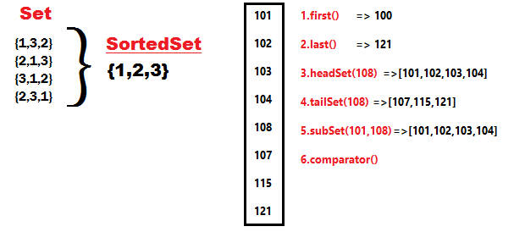
- Object first( )
- Object last( )
- SortedSet headSet(Object obj)
- SortedSet tailSet(Object obj)
- SortedSet subSet(Object start, Object end)

- Comparator comparator()
Used to get Default Natural sorting order
- Numbers Ascending order [1, 2, 3, 4, 5….]
- Strings Alphabetical Order [A, B, C, D, E…a,b,c,d …] (Unicode values)

Comparator comparable
public class TreeSetStringBuffer {
public static void main(String[] args) {
TreeSet t = new TreeSet();
t.add(new StringBuffer("A"));
t.add(new StringBuffer("X"));
t.add(new StringBuffer("O"));
t.add(new StringBuffer("L"));
System.out.println(t);
}
}
Exception in thread "main" java.lang.ClassCastException: java.lang.StringBuffer cannot be cast to java.lang.Comparable
If we are depending on Def. Natural SortingOrder objects should be homogeneous & Comparable. Otherwise we will get Runtime Exception java.lang.ClassCastException.
An object is said to be comparable if and only if corresponding class implements Comparable interface
Java.lang.String & all wrapper classes (Int, Float, Byte) already implements Comparable interface
public final class java.lang.String implements java.io.Serializable, java.lang.Comparable

Java.lang.StringBuffer doesn’t implements comparable interface
public final class java.lang.StringBuffer extends java.lang.AbstractStringBuilder implements java.io.Serializable,java.lang.CharSequence

i. Comparable Interface
It is present in java.lang. Package & it contains only one method compareTo()
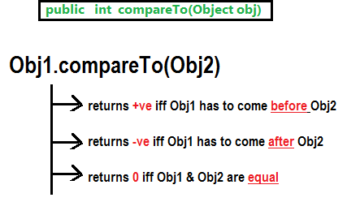
public class ComparableDemo {
public static void main(String[] args) {
System.out.println("A".compareTo("Z")); // 1-26 = -25
System.out.println("Z".compareTo("C")); // 26-3 = 23
System.out.println("A".compareTo("A")); // 1-1 = 0
// System.out.println("A".compareTo(null)); //R.E NPE
}
}

While adding Objects into TreeSet JVM will call compareTo() method
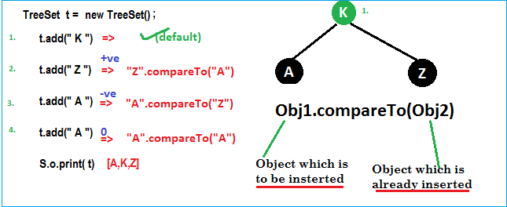

If default Natural sorting order not available or if we are not satisfied with default natural sorting order then we can go for customized sorting by using comparator
- Comparable for Default Natural Sorting Order
- Comparator for Customized sorting Order

ii. Comparator Interface
Comparator present in java.util package & it defines two methods compare (ob1, ob2) & equals (ob1)
public int compare(Object ob1, Object ob2);

public boolean equals(Object ob)
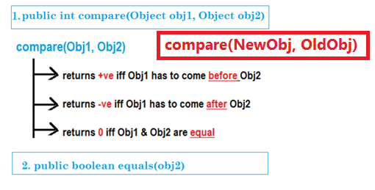
Whenever we are implementing comparator interface we should provide implementation only for compare () method & we are not required implementation for equals() method, because it is already available to our class from Object class through inheritance
Example: To insert integer Objects into TreeSet where Sorting Order is Descending order
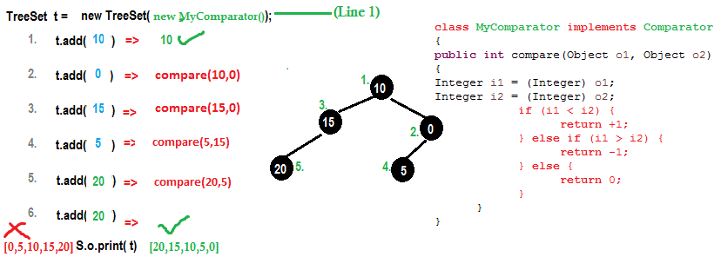
public class TreesetComp {
public static void main(String[] args) {
TreeSet t = new TreeSet(new MyComparator());
t.add(10);
t.add(0);
t.add(15);
t.add(5);
t.add(20);
t.add(20);
System.out.println(t);
}
}

class MyComparator implements Comparator {
@Override
public int compare(Object newObj, Object oldObj) {
Integer i1 = (Integer) newObj;
Integer i2 = (Integer) oldObj;
if (i1 < i2) {
return +1;
} else if (i1 > i2) {
return -1;
} else {
return 0;
}
}
}
[20, 15, 10, 5, 0]

At Line1, if we not passing MyComparator object then internally JVM will call compareTo() method which is for default Natural Sorting order.in this case output is [0,5,10,15,20].
At Line1, if we passing MyComparator object then JVM will call compare() method which is for customize Sorting order.in this case output is [20,15,10,5,0].
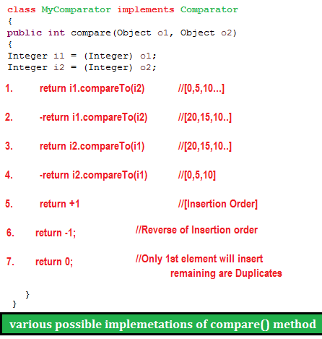
As the same way if we want to change String order we do as follows
public class TreesetStringComp {
public static void main(String[] args) {
TreeSet t = new TreeSet(new MyComparators());
t.add("HYDERABAD");
t.add("VIJAYAWADA");
t.add("BANGLORE");
t.add("VIZAG");
System.out.println(t);
}
}
class MyComparators implements Comparator {
public int compare(Object newObj, Object oldObj) {
String s1 = (String) newObj;
String s2 = (String) oldObj;
int i1 = s1.length();
int i2 = s2.length();
if (i1 < i2) {
return +1;
} else if (i1 > i2) {
return -1;
} else {
return 0;
}
}
}
[VIJAYAWADA, HYDERABAD, BANGLORE, VIZAG]

Comparable | Comparator
1.it is meant for Defalut Nartural Sorting order  2.present in java.lang package  3.it defines only one method compareTo()  4.String & all Wrapper classes implments Comparable interface | 1.it is meant for Customized Nartural Sorting order  2.present in java.util package  3.it defines 2 methods compare() & equals()  4.only 2 GUI classes Collator&RulebasedCollator implemets Comparator

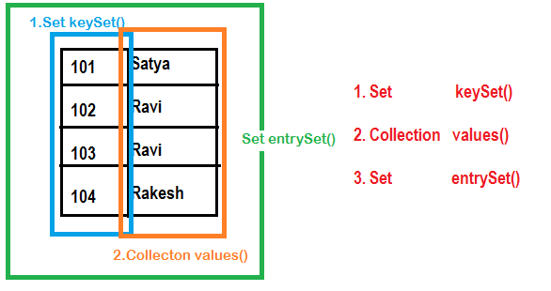

9.7.1 Entry Interface
One Row (pair of <K,V>) treated as an Entry
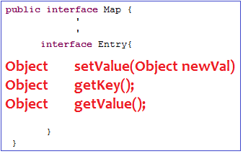

Hashtable

HashMap | Hashtable
HashMap is non synchronized  Performance is high because no threds waiting  Nulls allowed for both <Key & Value>  Introduced in 1.2 version | HashMap is synchronized  Performance is Low because threads may wait  Null is NOT allowed for both <Key & Value>  Introduced in 1.0 version(Legacy)

By default HashMap is non-synchronized but we can get Sychronized version of HashMap by usinh synchronizedMap () of collections class
HashMap m = new HashMap()
Map m1 = Collections.synchronizedMap(m)

9.7.4 IdentityHashMap

It is exactly same as HashMap (including methods&constructors) except following diffrences
In the case of Normal HashMap JVM will use .equals() method to identify Duplicate keys, which is ment for Content comparision
But, In the case of IdentityHashMap JVM will use == operator to identify Duplicate keys, which is ment for reference comparision or address comparision

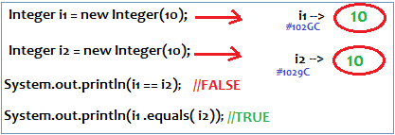
== is for reference comparision or address comparision

.equals () is for content comparision

HashMap Example | IdentityHashMap Example
public class IdentityHashMapDemo {  public static void main(String[] a) {  HashMap m = new HashMap();  m.put(new Integer(10), "Satya");  m.put(new Integer(10), "Surya");  System.out.println(m);  // {10=Surya}  }  }  {10=Surya} | public class IdentityHashMapDemo {  public static void main(String[] args)  {  IdentityHashMap m = new IdentityHashMap();  m.put(new Integer(10), "Satya");  m.put(new Integer(10), "Surya");  System.out.println(m);  // {10=Satya, 10=Surya}  }  }  {10=Satya, 10=Surya}

9.7.5 WeakHashMap
It is exactly same as HashMap except following difference
In the case of HashMap eventhough Object doesn’t have any reference it is NOT elegible for gc() if it is associated with HashMap that is HashMap dominates Garbage collector
But the case of WeakHashMap if Object doesn’t have any references it is elegible for gc() eenthough Object associated with WeakHashMap that is Garbage collector dominates WeakHashMap

This Temp class is common for HashMap & WeakHapMap Demo’s
class Temp {
@Override
public String toString() {
return "Temp";
}
@Override
protected void finalize() throws Throwable {
System.out.println("Finalize Called");
}
}

HashMap Demo with GC
public class HashMapdemo {
public static void main(String[] args) throws InterruptedException {
HashMap m = new HashMap();
Temp t = new Temp();
m.put(t, "Satya");
System.out.println(m);
t=null;
System.gc();
Thread.sleep(5000);
//main Thread Sleeping for 5 seconds
//Garbage collector takes control for 5 seconds
System.out.println(m);
}
}
{Temp=Satya}
{Temp=Satya}
In the above example Temp object is not eligible for gc() because it is associated with HashMap.in this case out put is {Temp=Satya} {Temp=Satya}

WeakHashMap Demo with GC
public class WeakHashMapdemo {
public static void main(String[] args) throws InterruptedException {
WeakHashMap m = new WeakHashMap();
Temp t = new Temp();
m.put(t, "Satya");
System.out.println(m);
t=null;
System.gc();
Thread.sleep(5000);
System.out.println(m);
}
}
{Temp=Satya}
Finalize Called
{}
In the above example Temp object is eligible for gc() because it is associated with HashMap.in this case out put is {Temp=Satya} Finalize Called {}

9.9 Legacy Classes on Map
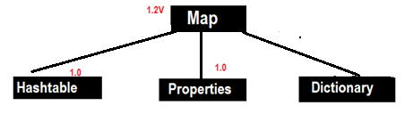

9.9.1 Hashtable
- Underlying D.S Hashtable for is Hashtable
- Insertion order is not preserved & it is based on Hashcode of keys
- DUPLICATE keys are NOT allowed & Values can be duplicated
- Hertogenious objects are allowed for both keys&values
- Null is NOT allowed for both key& value.otherwise we will get NullPointerException at runtime
- It implements Serializable, Clonable interfaces but not RandomAccess
- All methods are Synchronized, so Hashtable is Thread-Safe
- Hashtable is best choice for Search Operation
1. Hashtable h = new Hashtable () //16 capacity, Def. fill ratio = 0.75
Creates an empty Object with def. initial capacity 11 & def. fill ratio 0.75
2. Hashtable h = new Hashtable (int intialcapacity) // Def. fill ratio = 0.75
3. Hashtable h = new Hashtable (int intialcapacity, float fillRatio)
4. Hashtable h = new Hashtable (Map m)
class Test {
int i;
Test(int i) {
this.i = i;
}
@Override
public int hashCode() {
return i;
}
@Override
public String toString() {
return i + "";
}
}
public class HashtableDemo {
public static void main(String[] args) {
Hashtable h = new Hashtable();
h.put(new Test(5), "A");
h.put(new Test(2), "B");
h.put(new Test(6), "C");
h.put(new Test(15), "D");
h.put(new Test(23), "E");
h.put(new Test(16), "F");
System.out.println(h);
}
}
{6=C, 16=F, 5=A, 15=D, 2=B, 23=E}

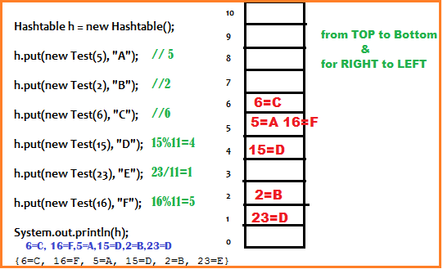

9.9.2 Properties
In our if any thing which changes frequently like Database names, username, password etc we use properties file to store those & java programe used to read properties file
1. Properties p = new Properties ()
KEY & Values must be String type

Methods
- String getProperty(String name);
- String setProperty(String name, value);
- Enumaration propertyNames();

- Void load(InputStream is)
Load properties from properties file into java properties Object

- Void store(OutputStream is, String commet)
Store java properties Object into properties file
uname=satya //abc.properties before
port=8080
public class PropertiesDemo {
public static void main(String[] args) throws Exception {
Properties p = new Properties();
FileInputStream fis = new FileInputStream("abc.properties");
p.load(fis);
System.out.println(p);
System.out.println("Uname : "+p.getProperty("uname"));

p.setProperty("port", "8080");
FileOutputStream fos = new FileOutputStream("abc.properties");
p.store(fos, "Port Number comment added");
}
}
#Port Number comment added //abc.properties After
#Mon Sep 12 20:38:33 IST 2016
uname=satya
port=8080
pwd=smlcodes

Multiple values in java.util.Properties
foo=1,2

String[] foos = properties.getProperty("foo").split(",");

12.Features by Version

Java4

RMI(1.1V)
RMI used to invoke methods which is running on one JVM from another JVM
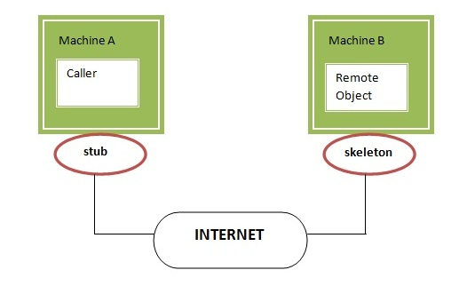
1. Stub
The stub is an object, acts as a gateway for the client side.if we invokes method on the stub object, it does the following tasks:
- It initiates a connection with remote Virtual Machine (JVM),
- It writes and sends (marshals) the parameters to the remote Virtual Machine (JVM),
- It waits for the result
- It reads (unmarshals) the return value or exception, and
2. Skeleton: The skeleton is an object, acts as a gateway for the server side object. All the incoming requests are routed through it. When the skeleton receives the incoming request, it does the following tasks:
- It reads the parameter for the remote method
- It invokes the method on the actual remote object, and
- It writes and transmits (marshals) the result to the caller.
Steps to Create Skeleton / Client
- Create an Interface by implementing Remote interface with methods you want to share
- Create a Class by exctending UnicastRemoteObject & also implement above methods
- Create a class to Share the Remote Class Object over the Network
1. Interface by implementing Remote
public interface RemoteInterface extends Remote {
public String show(String name);
}

2.Class by exctending UnicastRemoteObject
public class RemoteClass extends UnicastRemoteObject implements RemoteInterface {
protected RemoteClass() throws RemoteException {
super();
}
@Override
public String show(String name) {
// TODO Auto-generated method stub
return "Your Name Is : " + name;
}
}

3. Create a class to Share the Remote Class Object over the Network
public class RemoteObject {
public static void main(String[] args) throws RemoteException, MalformedURLException, AlreadyBoundException {
RemoteInterface obj = new RemoteClass();
Naming.rebind("obj", obj);
}
}

4.stub class - Client
public class Client {
public static void main(String args[]) throws Exception
RemoteInterface st=(RemoteInterface) Naming.lookup("rmi://"+args[0]+ "/obj");
System.out.println(st.show("Satya"));
}
}

JDBC(1.1V)
We know it already.

Assertions
Assert keyword is used to check the given statement is TRUE or FALSE
There are two types of using assert in our program
1. assert (boolean expression); //Simple assert
2. assert (boolean expression1) : (anytype expression2); //Agumented assert
Assertion is disabled by default. To enable we have to use java –ea classname or -enableassertions
The main advantage of assert is for DEBUGGING. If we write s.o.p’s for debugging after completion of code we have to munually remove the s.o.p’s. But if we use assertions for debugging after completion of code we don’t need to remove the code, just DISABLING assertion is enough
11.1.1 Simple assert
assert (boolean expression);

- Here the Expression Should be Boolean type.
- If expression is TRUE it wont return anything,
- Otherwise it will throws Runtime Exception : java.lang.AssertionError: Not valid
public class AssertDemo {
public static void main(String[] args) {
int i = 100;
assert (i>10);
System.out.println(i); //100
}
}
If we give int i = 10; it will throws java.lang.AssertionError: Not valid

11.1.2 Agumented assert
2. assert (boolean expression1) : (anytype expression2); //Agumented assert
Expression2 is used to Disply some message along with Error Message
- Here the 1st Expression Should be Boolean type, 2nd Expression can be Any type
- If expression is TRUE it wont return anything,
- Otherwise it will throws Runtime Exception : java.lang.AssertionError: expression2

public class AssertDemo {
public static void main(String[] args) {
int i = 1;
assert (i > 10) : "This is Anytype";
System.out.println(i);
}
}
Exception in thread "main" java.lang.AssertionError: This is Anytype
at features.AssertDemo.main(AssertDemo.java:6)
To ENABLE assertions we have to use java –ea classname or –enableassertions
To DISABLE assertions we have to use java –da classname or –disableassertions
To ENABLE assertions in ECLIPSE File Run As Run Config.,>Vm args = -ea > Save>Run

RegExp
Java.util.regex or Regular Expression is an API to define pattern for searching or manipulating strings. It is widely used to define constraint on strings such as password and email validation.
It provides following classes are widely used in java regular expression.
- Pattern class -it represents the Complied pattern
- Matcher class -used for performing matching operations on complied pattern
- PatternSyntaxException - checks syntax error in a regular expression pattern.

1. Pattern class it represents the Complied pattern
Method | Description
static Pattern compile(String regex) | Compiles the given regex and return the instance of pattern.
Matcher matcher(CharSequence input) | Retuns charsequence to be comapir with patten
static boolean  matches(String regex, String CharSequence) | Direcly we can compare Expression with Sequence
String pattern() | returns the regex pattern.

2. Matcher class -used for performing matching operations on complied pattern
Method | Description
boolean matches() | Test whether the regular expression matches the pattern.
boolean find() | Finds the next expression that matches the pattern.
boolean find(int start) | Finds the next expression that matches the pattern from the given start number.
String group() | Returns the matched subsequence.
int start() | Returns the starting index of the matched subsequence.
int end() | Returns the ending index of the matched subsequence.
int groupCount() | Returns the total number of the matched subsequence.

public class REDemo {
public static void main(String[] args) {
Pattern p = Pattern.compile(".a");// only 2 char end with a
Matcher m = p.matcher("sa");
boolean b1 = m.matches();
System.out.println(b1);//TRUE

boolean b2 = Pattern.matches("s.", "sa"); //only 2 char Start with s
System.out.println(b2); //TRUE
}
}

1. Regex Character classes
Character Class | Description
[abc] | a, b, or c (simple class)
[^abc] | Any character except a, b, or c (negation)
[a-zA-Z] | a through z or A through Z, inclusive (range)
[a-d[m-p]] | a through d, or m through p: [a-dm-p] (union)
[a-z&&[def]] | d, e, or f (intersection)
[a-z&&[^bc]] | a through z, except for b and c: [ad-z] (subtraction)
[a-z&&[^m-p]] | a through z, and not m through p: [a-lq-z](subtraction)

2. Regex Quantifiers
The quantifiers specify the number of occurrences of a character.
Regex | Description
X? | X occurs once or not at all
X+ | X occurs once or more times
X* | X occurs zero or more times
X{n} | X occurs n times only
X{n,} | X occurs n or more times
X{y,z} | X occurs at least y times but less than z times
3. Regex Metacharacters
The regular expression metacharacters work as a short codes.
Regex | Description
. (dot) | Any character (may or may not match terminator)
\d | Any digits, short of [0-9]
\D | Any non-digit, short for [^0-9]
\s | Any whitespace character, short for [\t\n\x0B\f\r]
\S | Any non-whitespace character, short for [^\s]
\w | Any word character, short for [a-zA-Z_0-9]
\W | Any non-word character, short for [^\w]
\b | A word boundary
\B | A non word boundary

public class REDemo {
public static void main(String[] args) {
S.o.p("1.Regex Character classes\n--------------");
S.o.p(Pattern.matches("[amn]", "abcd"));//false (not a or m or n)
S.o.p(Pattern.matches("[amn]", "a"));//true (among a or m or n) S.o.p(Pattern.matches("[amn]", "ammmna"));//false(m &a morethan once)

S.o.p("\n2.Regex Quantifiers\n--------------");
S.o.p("? quantifier ....");
S.o.p(Pattern.matches("[amn]?", "a"));//true (a or m or n comes one time)
S.o.p(Pattern.matches("[amn]?", "aaa"));//false (a comes more than one time)
S.o.p(Pattern.matches("[amn]?", "aammmnn"));//false (a m and n comes more than one time)

S.o.p("+ quantifier ....");
S.o.p(Pattern.matches("[amn]+", "a"));//true (a or m or n once or more times)
S.o.p(Pattern.matches("[amn]+", "aaa"));//true (a comes more than one time)

S.o.p("\n3.Regex Metacharacters\n--------------\n");
S.o.p(Pattern.matches("\\d", "abc"));//false (non-digit)
S.o.p(Pattern.matches("\\d", "1"));//true (digit and comes once)
S.o.p(Pattern.matches("\\d", "4443"));//false (digit but comes more than 1)
}
}

Logging API
In common we use System.out.println () statements for DEBUGGING. But these are printed at console and they will lost after closing the Console.so these results are not savable
To overcome these problems apache released Log4j. With Log4j we can store the flow details of our Java/J2EE in a file or databases
We have mainly 3 components to work with Log4j
- Logger class -for printing LOG messages
- Appender interface -to store messages in Files/Databases
- Layout -which Fomate the message should Save(HTML,Text,etc)
1. Logger class
- Logger is a class, in org.apache.log4j.*
- We need to create Logger object one per java class,it will enables Log4j in our java class
- Logger methods are used to generate log statements in a java class instead of sopls
- So in order to get an object of Logger class, we need to call a static factory method
static Logger log = Logger.getLogger(YourClassName.class.getName())
We have following methods to print debugging statements on Logger
- log.debug (“ ”)
- log.info (“”)
- log.warn (“”)
- log.error (“”)
- log.fatal (“”)
Here human identification purpose names are different, all 5 methods will print one text message only.
Priority Order: debug < info < warn < error < fatal

2. Appender interface
Appender job is to write the messages into the external file or database or SMTPIn log4j we have different Appender implementation classes
- ConsoleAppender [ Writing into console ]
- FileAppender [ writing into a file ]
- JDBCAppender [ For Databases ]
- SMTPAppender [sent logs via Mails ]
- SocketAppender [ For remote storage ]
3. Layout
This component specifies the format in which the log statements are written into the destination by the appender
- SimpleLayout
- PatternLayout
- HTMLLayout
- XMLLayout
Simple Hello world

public class LogDemo {
public static void main(String[] args) {
Logger logger = Logger.getLogger(LogDemo.class.getName());
Layout layout = new SimpleLayout();
Appender a = new ConsoleAppender(layout);
logger.addAppender(a);

logger.debug("Debug Message");
logger.info("Info Message");
logger.warn("Warning Message");
logger.error("Error Message");
logger.fatal("Fatal Message");
}
}
In above Example we used Layout, Appenders programmatically which is NOT RECOMMENDED.we have to use log4j.properties to configure those.
Log4j.properties Structure
log4j.rootLogger=DEBUG, CONSOLE, LOGFILE
log4j.appender.CONSOLE=
log4j.appender.CONSOLE.layout=
log4j.appender.CONSOLE.layout.ConversionPattern=
log4j.appender.LOGFILE=
log4j.appender.LOGFILE.File=
log4j.appender.LOGFILE.MaxFileSize=
log4j.appender.LOGFILE.layout=
log4j.appender.LOGFILE.layout.ConversionPattern=
If we use .properties file, we no need to import any related classes into our java class
if we wrote log4j.rootLogger = WARN,abc then it will prints the messages in l.warn(), l.error(), l.fatal() and ignores l.debug(), l.info(). Means >Warn level only it prints
Make sure LOG file should be placed in /src Folder
Example programe to Store LOG’s in a FILE
public class LogDemo {
static Logger logger = Logger.getLogger(LogDemo.class.getName());
public static void main(String[] args) {
logger.debug("Debug Message");
logger.info("Info Message");
logger.warn("Warning Message");
logger.error("Error Message");
logger.fatal("Fatal Message");
}
}

Log4j.properties
log4j.rootLogger = DEBUG,abc
log4j.appender.abc = org.apache.log4j.FileAppender
log4j.appender.abc.file = logfile.log
log4j.appender.abc.layout = org.apache.log4j.SimpleLayout
logfile.log
DEBUG - Debug Message
INFO - Info Message
WARN - Warning Message
ERROR - Error Message
FATAL - Fatal Message
The above example only saves log’s to file. You can’t see logs on console .if want both use below. Use same java program, but change log4j.properties file

log4j.properties in Real world Applications
log4j.rootLogger=DEBUG,CONSOLE,LOGFILE
log4j.appender.CONSOLE=org.apache.log4j.ConsoleAppender
log4j.appender.CONSOLE.layout=org.apache.log4j.PatternLayout
log4j.appender.CONSOLE.layout.ConversionPattern=%-4r [%t] %-5p %c %x – %m%n
log4j.appender.LOGFILE=org.apache.log4j.RollingFileAppender
log4j.appender.LOGFILE.File=logfile.log
log4j.appender.LOGFILE.MaxFileSize=1kb
log4j.appender.LOGFILE.layout=org.apache.log4j.PatternLayout
log4j.appender.LOGFILE.layout.ConversionPattern=[%t] %-5p %c %d{dd/MM/yyyy HH:mm:ss} – %m%n
[main] DEBUG log.LogDemo 15/09/2016 19:23:38 â?? Debug Message
[main] INFO log.LogDemo 15/09/2016 19:23:38 â?? Info Message
[main] WARN log.LogDemo 15/09/2016 19:23:38 â?? Warning Message
[main] ERROR log.LogDemo 15/09/2016 19:23:38 â?? Error Message
[main] FATAL log.LogDemo 15/09/2016 19:23:38 â?? Fatal Message

Java5 (2005)

Annotations
Java Annotation is a tag that represents the metadata i.e. attached with class, interface, methods or fields to indicate some additional information which can be used by java compiler and JVM.
Annotations have a number of uses, among them:
- Information for the compiler — Annotations can be used by the compiler to detect errors or suppress warnings.
- Compile-time and deployment-time processing — Software tools can process annotation information to generate code, XML files, and so forth.
- Runtime processing — Some annotations are available to be examined at runtime

The annotation can include elements, which can be named or unnamed, and there are values for those elements:
@Author(
name = "Benjamin Franklin",
date = "3/27/2003"
)
class MyClass() { ... }

If there is just one element named value, then the name can be omitted, as in:
@SuppressWarnings("unchecked")
void myMethod() { ... }

If the annotation has no elements, then the parentheses can be omitted
example : @Override

It is also possible to use multiple annotations on the same declaration:
@Author(name = "Jane Doe")
@EBook
class MyClass { ... }

If the annotations have the same type, then this is called a repeating annotation Repeating annotations are supported as of the Java SE 8 release.
@Author(name = "Jane Doe")
@Author(name = "John Smith")
class MyClass { ... }

Java Custom annotations or Java User-defined annotations are easy to create and use. The @interface element is used to declare an annotation.
- Method should not have any throws clauses
- Method should return something
- Method should not have any parameter.
- It may assign a default value to the method.
@interface MyAnnotation{
int value() default 0;
}

Example
Suppose Every class in a given Project should contain author info. Writing Author info in each every class is deficult like below
public class GenrateWorkSheet extends DataList {

// Author: John Doe
// Date: 3/17/2002
// Current revision: 6
// Last modified: 4/12/2004
// By: Jane Doe
// Reviewers: Alice, Bill, Cindy

// class code goes here

}

By Using Annotation we can provide above information.for doing this we need to create an annotation & all properties should define using methods.
@interface ClassPreamble {
String author();
String date();
int currentRevision() default 1;
String lastModified() default "N/A";
String lastModifiedBy() default "N/A";
// Note use of array
String[] reviewers();
}

Once annotation reday, you can write that annotation top of the each class with values
@ClassPreamble (
author = "John Doe",
date = "3/17/2002",
currentRevision = 6,
lastModified = "4/12/2004",
lastModifiedBy = "Jane Doe",
// Note array notation
reviewers = {"Alice", "Bob", "Cindy"}
)
public class Generation3List extends Generation2List {
// class code goes here

}

Autoboxing
The automatic conversion of primitive data types into its equivalent Wrapper type is known as boxing and opposite operation is known as unboxing.
Upto JDK 1.4, all the data structures of Java stores only objects and when retrieved returns objects. Autoboxing permits to store data types directly in DS and retrieve back data types.

Generics
Generics are introduced in Java 1.5 Version to solve Type-safity & Type-casting problems
public class Student {
public static void main(String[] args) {
ArrayList l = new ArrayList(); //1
l.add("Satya");
String s = (String) l.get(0); //2
System.out.println(s);
}
}
- At line 1. ArrayList is NOT generic type – so we can add any type of elements results Type-Safity
- At line 2. It returns added String data as Object. So manullay we have to Type-cast to String
To resolve above problems Genrics are indrodued
public class Student {
public static void main(String[] args) {
ArrayList<String> l = new ArrayList<String>(); // 1
l.add("Satya");
String s = l.get(0); // 2
System.out.println(s);
}
}

Generics solves ClassCastException, beacause TYPE-CHECKING done at COMPILE-TIME itself
Generics can be used in following areas
- Class level
- Interface level
- Constructor level.
- Method level
Sample Generic class
class SmlGen<T> {
T obj;

void add(T obj) {
this.obj = obj;
}

T get() {
return obj;
}
}
The <T> indicates that it can refer to any type (like String, Integer, and Student etc.). The type you specify for the class, will be used to store and retrieve the data
1. Type Parameter<T> Naming Conventions
In above <T> refers any type. Similary we have to follow below naming convensions to where to use which Naming conevsions. It improves readability. These are NOT compulsory but recommended to use
- T – Type - Any Type, can be use any level (Class, Interface, Methods...)
- N – Number - Indicates it allows Number Types (int,long,float etec)
- E – Element - Exclusivly used in Collection (ArrayList<E>)
- K – Key - Map KEY area
- V – Value - Map Value area
- S,U,V etc. - 2nd, 3rd, 4th types

1. Genrics at Class /Method /Constrcutor level
A generic class is defined with the following format:
class name<T1, T2, ..., Tn> {
---
}

class SmlGen<T> { //1.Class Level
T obj;
public SmlGen() {
}

public SmlGen(T obj) { //2.Constrcutor Level
this.obj = obj;
}

void add(T obj) {
this.obj = obj;
}

T get() { //3.Method Level
return obj;
}
}

public class Student {
public static void main(String[] args) {
SmlGen<String> s = new SmlGen<String>();
s.add("Satya");
System.out.println(s.get());
}
}

2. Genrics at Interface level
A generic interface is same as gereric class.
public interface List<T> extends Collection<T> {
...
}
2. Wildcard in Generics
? Operator is used to represents wilcards in generics. We have to types of Wildcards
    - Unbounded wildcards
    - Bounded wildcards
1. Unbounded wildcards
Unbounded wildcard looks like <?> - means the generic can be any type.it is not bounded with anytype.

2. Bounded wildcards
<? extends T> and <? super T> are examples of bounded wildcards
<? extends T> : means it can accept the Child class Objects of the type<T>
<? super T> : means it can accept the Partent class Objects of the type<T>

Covariant Return Type (Java 5)
Before Java5, it was not possible to override any method by changing the return type. But now, since Java5, it is possible to override method by changing the return type if subclass overrides any method whose return type is Non-Primitive but it changes its return type to subclass type.

Enhanced for loop
- For-each loop introduced in Java 1.5 version as an enhancement of traditional for-loop
- Main advantage is we don’t need to write extra code traverse over array / collections
- Mainly used for traverse on Array Elements & Collection Elements
for (Datatype temp_variable : Array/Collection Variable){}

11.2.1 for-each loop on Array Elements
public class Foreach {
public static void main(String[] args) {
int i[] = { 1, 2, 3, 4, 5, 6, 7, 8, 9, 10 };
for (int b : i) {
System.out.print(b+", ");
}
}
}
1, 2, 3, 4, 5, 6, 7, 8, 9, 10,

11.2.2 for-each loop on Collection Elements
public class Foreach {
public static void main(String[] args) {
ArrayList<String> l = new ArrayList<String>();
l.add("A");
l.add("B");
l.add("C");
l.add("D");
l.add("E");
for (String s : l) {
System.out.print(s + ",");
}
}
}
A, B, C, D, E

Varargs
Some times we don’t know no.of arguments used in our method implementation.var…args are introduced in 1.5v to solve these type of situations
static returntype methodname(Datatype … variblename)
public class Varargs {
static void show(String… var) {
System.out.println(“Show() called”);
}
public static void main(String[] args) {
Varargs v = new Varargs();
v.show();
v.show(“A”);
v.show(“A”, “B”, “C”);
}
}
Show() called
Show() called
Show() called

Rules for using Var-args
1. Var-args must be as the last argument in method signature
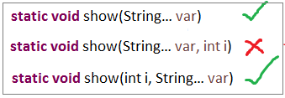

2. Only one Var-arg is allowed per a Method
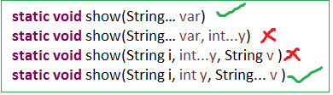

Enums
Enum in java is a data type that contains fixed set of constants.
- enums improves type safety
- easily used in switch
- enum can be traversed
- enum class is a just like normal class, we can write FIELDS, Constrcutors, Methods in enum class
- enum CANNOT extend any class because it internally extends Enum class
- enum may implement many interfaces
ALL fields in Enums by Default PUBLIC STATIC FINAL
1. Simple ENUM Example

enum Days {
MONDAY, TUESDAY, WEDNESDAY, THURSDAY, FRIDAY, SATURDAY, SUNDAY
}

public class EnumDemo {
public static void main(String[] args) {
for (Days s : Days.values()) {
System.out.print(s + ",");
}
}
}
MONDAY, TUESDAY, WEDNESDAY, THURSDAY, FRIDAY, SATURDAY, SUNDAY,

2. Enum with Values
To write Enum with values we have to follow below steps
- Enum values must be placed inside ( ) MONDAY(1)
- Take public instance variable to Store enum value public int Enum_Value;
- Write private constructor which can take enum value as argument private Days(int Enu_Val)
enum Days {
MONDAY(1), TUESDAY(2), WEDNESDAY(3), THURSDAY(4), FRIDAY(5), SATURDAY(6), SUNDAY(7);
public int Enum_Value;
private Days(int Enum_Value) {
this.Enum_Value = Enum_Value;
}
}
public class EnumDemo {
public static void main(String[] args) {
for (Days s : Days.values()) {
System.out.println(s + ":"+s.Enum_Value);
}
}
}
MONDAY :1, TUESDAY:2, WEDNESDAY:3, THURSDAY :4, FRIDAY:5, SATURDAY:6 SUNDAY:7

Static imports
The static import feature of Java 5 facilitate the java programmer to access any static member of a class directly. There is no need to qualify it by the class name.
From 1.5 version onwords we can access any static member of a class directly. There is no need to qualify it by the class name.
import static java.lang.System.*;

public class StaticImport {
public static void main(String[] args) {
out.println("Static Import");
}
}

C-lang printf()
printf() is an extra method added to PrintStream class from JDK 1.5 version. printf() is used to print at command-prompt
public class PrintfDemo
{
public static void main(String args[])
{
boolean hot = false;
char alphabet = 'A';
int rate = 5;
float temperature = 12.3456789f;

System.out.printf("The boolean hot: %b", hot); // place holder b for boolean
System.out.printf("\nThe char alphabet: %c", alphabet); // c for char
System.out.printf("\nThe int rate: %d", rate); // d for int
System.out.printf("\nThe float marks is %f", temperature); // f for float
System.out.printf("\n value prefixed with 4 zeros: %04d", rate);// filling with zeros
System.out.printf("\float temp %.3f", temperature); // precision to three decimal values
System.out.printf("\nThe float temperature in exponential form: %e", temperature);
System.out.printf("\n%s, %s and also %s belong to java.lang package", "System","String","Math");
System.out.printf("\ntemperature is %4.2f", temperature); // width is 4 and precision to 2 decimal points
}
}
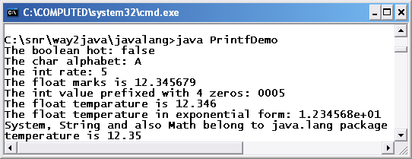
Java6 not many fetaures

Java 7(2011)

Underscores in Numeric Literals (Java 7)
Java allows you to use underscore in numeric literals.
- You cannot use underscore at the beginning or end of a number.
- You cannot use underscore adjacent to a decimal point in a floating point literal.( 10._0)
- You cannot use underscore prior to an F or L suffix (long a = 10_100_00_L;)
- added in Java 7. You can have underscores in numbers to make them easier to read:
int million1 = 1000000;
int million2 = 1_000_000;

double notAtStart = _1000.00; // DOES NOT COMPILE
double notAtEnd = 1000.00_; // DOES NOT COMPILE

double notByDecimal = 1000_.00; // DOES NOT COMPILE

String in switch statement (Java 7)
public class StringInSwitchStatementExample {
public static void main(String[] args) {
String game = "Cricket";
switch(game){
case "Hockey":
System.out.println("Let's play Hockey");
break;
case "Cricket":
System.out.println("Let's play Cricket");
break;
case "Football":
System.out.println("Let's play Football");
}
}
}

The try-with-resources (Java 7)
the try-with-resources statement is a try statement that declares one or more resources. The resource is as an object that must be closed after finishing the program. The try-with-resources statement ensures that each resource is closed at the end of the statement execution.
You can pass any object that implements java.lang.AutoCloseable, which includes all objects which implement java.io.Closeable

Caching Multiple Exceptions by single catch (Java 7)
Java allows you to catch multiple type exceptions in a single catch block. It was introduced in Java 7 and helps to optimize code.You can use vertical bar (|) to separate multiple exceptions in catch block.

Diamond operator <>, removes right side of generics
you can replace the type arguments with an empty set of type parameters (<>). This pair of angle brackets is informally called the diamond.
The following approach is used in Java 6 and prior version.
Ex. List<Integer> list = new List<Integer>();

Now, you can use the following new approach introduced in Java 7.
Ex. List<Integer> list = new List<>(); // Here, we just used diamond

Java8(2014)

Functional Interfaces (Java 8)
An Interface that contains exactly one abstract method is known as functional interface. It can have any number of default, static methods but can contain only one abstract method. It can also declare methods of object class
@FunctionalInterface
interface sayable{
void say(String msg);
}

Lambda Expressions (Java 8)
The Lambda expression is used to provide the implementation of an interface which has functional interface

Stream (Java 8)
Another major change introduced Java 8 Streams API, which provides a mechanism for processing a set of data in various ways that can include filtering, transformation, or any other way that may be useful to an application.
Streams API in Java 8 supports a different type of iteration where you simply define the set of items to be processed, the operation(s) to be performed on each item, and where the output of those operations is to be stored.

Default Methods & Static methods Interface (Java 8)
Java 8 allows you to add non-abstract methods in interfaces. These methods must be declared default methods.Default methods enable you to add new functionality to the interfaces of your libraries and ensure binary compatibility with code written for older versions of those interfaces.
public interface Moveable {
default void move(){
System.out.println("I am moving");
}
}
static void isNull(String str) {
System.out.println("Interface Null Check");
}
If class willingly wants to customize the behavior of move() method then it can provide it’s own custom implementation and override the method.in this case we must remove default keyword.
Static methods : Java interface static method is similar to default method except that we can’t override them in the implementation classes.

Java 8 Date/Time API (Java 8)
Date class has even become obsolete. The new classes intended to replace Date class are LocalDate, LocalTime and LocalDateTime.
- The LocalDate class represents a date. There is no representation of a time or time-zone.
- The LocalTime class represents a time. There is no representation of a date or time-zone.
- The LocalDateTime class represents a date-time. There is no representation of a time-zone
LocalDate localDate = LocalDate.now();
LocalTime localTime = LocalTime.of(12, 20);
LocalDateTime localDateTime = LocalDateTime.now();
OffsetDateTime offsetDateTime = OffsetDateTime.now();
ZonedDateTime zonedDateTime = ZonedDateTime.now(ZoneId.of("Europe/Paris"));

Duration class is a whole new concept brought first time in java language. It represents the time difference between two time stamps.
Duration duration = Duration.ofMillis(5000);
duration = Duration.ofSeconds(60);
duration = Duration.ofMinutes(10);

Duration deals with small unit of time such as milliseconds, seconds, minutes and hour. They are more suitable for interacting with application code. To interact with human, you need to get bigger durations which are presented with Period class.
Period period = Period.ofDays(6);
period = Period.ofMonths(6);
period = Period.between(LocalDate.now(), LocalDate.now().plusDays(60));

Java9 (2017)

JShell: The Java Shell (REPL)
It is an interactive Java Shell tool, it allows us to execute Java code from the shell and shows output immediately. JShell is a REPL (Read Evaluate Print Loop) tool and run from the command line.

Module System (Project Jigsaw)
In earlier versions of Java, there was no concept of module to create modular Java applications, that why size of application increased and difficult to move around. Even JDK itself was too heavy in size, in Java 8, rt.jar file size is around 64MB.
To deal with situation, Java 9 restructured JDK into set of modules so that we can use only required module for our project
Create a file module-info.java, inside this file, declare a module by using module identifier and provide module name same as the directory name that contains it. In our case, our directory name is com.javatpoint.

Interface Private Methods
In Java 9, we can create private methods inside an interface. Interface allows us to declare private methods that help to share common code between non-abstract methods / Default methods.
interface Sayable{
default void say() {
saySomething();
}
// Private method inside interface
private void saySomething() {
System.out.println("Hello... I'm private method");
}
}
public class PrivateInterface implements Sayable {
public static void main(String[] args) {
Sayable s = new PrivateInterface();
s.say();
}
}

Multi-Release JAR Files
Previously, you had to package all classes into a jar file and drop in the classpath of the another application, which wish to use it.
Using multi-release feature, now a jar can contains different versions of a class – compatible to different JDK releases. The information regarding different versions of a class, and in which JDK version which class shall be picked up by class loaded, is stored in MANIFEST.MF file.

Java10 (mar-2018) (Java SE 10.0.2 july-18)

Local Variable Type Inference
Java has now var style declarations. It allows you to declare a local variable without specifying its type. The type of variable will be inferred from type of actual object created. It claims to be the only real feature for developers in JDK 10
var str = "Hello world";

Garbage-Collector Interface improvements

Garbage collection
- In C/C++, programmer is responsible for both creation and destruction of objects. Usually programmer neglects destruction of useless objects. Due to this negligence, at certain point, for creation of new objects, sufficient memory may not be available and entire program will terminate abnormally causing OutOfMemoryErrors.
- But in Java, the programmer need not to care for all those objects which are no longer in use. Garbage collector destroys these objects.
- Garbage collector is best example of Daemon thread as it is always running in background.
- Main objective of Garbage Collector is to free heap memory by destroying unreachable objects

The ways to make an object eligible for Garbage Collector
Even though the programmer is not responsible for destruction of objects it’s good programming practice to make an object eligible for Garbage Collector if it is no longer required.
The following are different ways for this

1.Nullifying the reference Variable
If an object is no longer required assign null to all its reference variables.
Student s1 = new Student();
Student s2 = new Student();
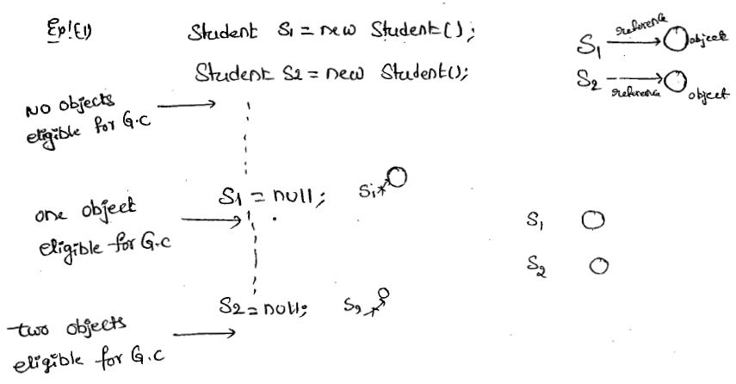

2. Reassigning the reference Variable
If an object is nolonger required then, assigning its reference varibles to some other objects then that old object automatically eligible for garbage collection.
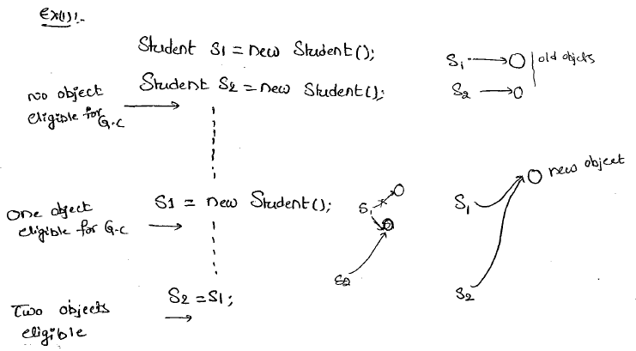

3.The Objects Created inside a method
The objects which are created in a method are by default eligible for Garbage Collector once the method completes.
Case 1:
class Test
{
public static void main(String arg[])
{
m1();
//Two Objects s1,s2 eligible for gc

}
public static void m1()
{
Student s1 = new Student();
Student s2 = new Student();
//No Objects eligible for gc
}
}

Case 2:
class Test
{
public static void main(String arg[])
{
Student s = m1();
//One Object s2 eligible for gc

}
public static Student m1()
{
Student s1 = new Student();
Student s2 = new Student();
return s1;//returning s1
}
}

4. The Island of Isolation
Object 1 references Object 2 and Object 2 references Object 1. Neither Object 1 nor Object 2 is referenced by any other object. That’s an island of isolation.
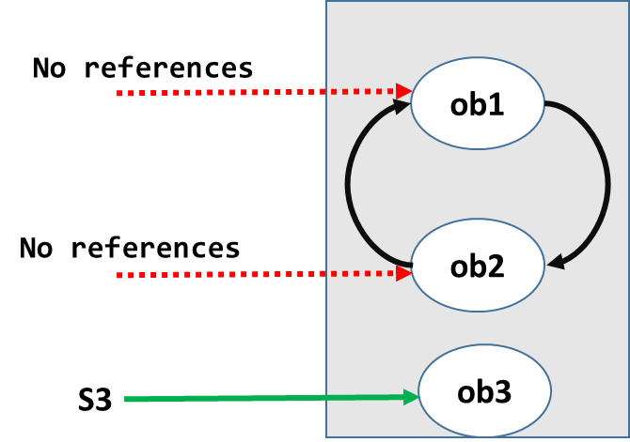
Basically, an island of isolation is a group of objects that reference each other but they are not referenced by any active object in the application. Strictly speaking, even a single unreferenced object is an island of isolation too.
class Test
{
Test i;
public static void main(String[] args)
{
Test t1 = new Test();
Test t2 = new Test();
Test t3 = new Test();
t1.i = t2;
t2.i = t3;
t3.i = t1;

t1 = null;
//No Object eligible for Garbage Collector

t2 = null;
//No Object eligible for Garbage Collector

t3 = null;
//All Objects eligible for Garbage Collector

}
}

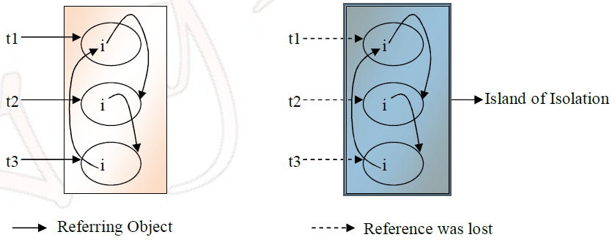

5.Static varables Garbage Collection
Static variables cannot be eligible for garbage collection while the class is loaded. They can be collected when the respective class loader drops the class or is itself collected for garbage.

https://www.geeksforgeeks.org/island-of-isolation-in-java/

The methods to request JVM to run Garbage Collector
We can request JVM to run Garbage Collector but there is no guarantee whether JVM accepts our request or not. We can do this by using the following ways.
1.By System class
‘System’ class contains a static ‘gc’ method for requesting JVM to run Garbage Collector.
System.gc();

2.By Using Runtime Class
A java application can communicate with JVM by using Runtime Object. We can get Runtime Object as follows.
Runtime runtime = Runtime.getRuntime();
Runtime.gc()
Once we get Runtime Object we can apply the following methods on that object.
freeMemory(): returns the free memory available in the loop
totalMemory(): returns heap size
gc(): for requesting JVM to run GarbageCollector
gc() method available in the System class is static method but gc() method available in Runtime classis an instance method.

finalize()
- Just before destroying any object Garbage Collector always calls finalize() to perform clean up activities.
- finalize() is available in the Object class which is declared as follows.
protected void finalize() throws Throwable
{
}

case1: Garbage Collector always calls finalize() on the Object which is eligible for Garbage Collector and the corresponding class finalize method will be executed.
Ex:
class Test
{
public static void main(String arg[])
{
String s = new String("raju");
//Test s = new Test();
s = null;
System.gc();
System.out.println("end of main method");
}
public void finalize()
{
System.out.println("finalize method called");
}
}
O/P:- end of main method.
In this case String Object is eligible for G.C and hence String class finalize() method has been executed.
In the above program if we are replacing String Object with Test Object then Test class finalize() will be executed.In this case O/P is end of main method.
finalize method called
end of main method

case2: we can call finalize() explicitly in that case it will execute just like a normal method and object won’t be destroyed.
While executing finalize() method if any exception is uncaught it is simply ignored by the JVM but if we are calling finalize method explicitly and if an exceptions is uncaught then the program will be terminated abnormally.
class Test
{
public static void main(String arg[])
{
Test s = new Test();
//s.finalize();
s = null;
System.gc();
System.out.println("End of main method");
}
public void finalize()
{
System.out.println("finalize method");
System.out.println(10/0);
}
}
O/P:- finalize method
end of main method

Types of Garbage Collectors
When an object is no longer used, the garbage collector reclaims the underlying memory and reuses it for future object allocation. This means there is no explicit deletion and no memory is given back to the operating system.
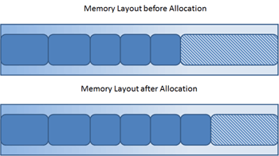
Java has four types of garbage collectors,
- Serial Garbage Collector
- Parallel Garbage Collector
- CMS Garbage Collector
- G1 Garbage Collector

Each of these four types has its own advantages and disadvantages. Most importantly, we the programmers can choose the type of garbage collector to be used by the JVM. We can choose them by passing the choice as JVM argument

1. Serial Garbage Collector
- It is designed for the single-threaded environments.
- It uses just a single thread for garbage collection.
- It freezes(stops) all the application threads while performing garbage collection.
- it may not be suitable for a server environment. It is best suited for simple command-line programs.
Turn on the -XX:+UseSerialGC JVM argument to use the serial garbage collector.

2. Parallel Garbage Collector
- It is the default garbage collector of the JVM.
- It uses multiple threads for garbage collection.
- Similar to serial garbage collector this also freezes(siops) all the application threads while performing garbage collection.

3. CMS Garbage Collector
Concurrent Mark Sweep (CMS) garbage collector uses multiple threads to scan the heap memory to mark instances for eviction and then sweep the marked instances.
Turn on the XX:+USeParNewGC JVM argument to use the CMS garbage collector.

4. G1 Garbage Collector
- G1 garbage collector is used for large heap memory areas.
- It separates the heap memory into regions and does collection within them in parallel.
- G1 also does compacts the free heap space on the go just after reclaiming the memory.
- G1 collector prioritizes the region based on most garbage first.
Turn on the –XX:+UseG1GC JVM argument to use the G1 garbage collector.

Java 8 Improvement
Turn on the -XX:+UseStringDeduplication JVM argument while using G1 garbage collector. This optimizes the heap memory by removing duplicate String values to a single char[] array. This option is introduced in Java 8 u 20.
Given all the above four types of Java garbage collectors, which one to use depends on the application scenario, hardware available and the throughput requirements.

Garbage Collection JVM Options
Type of Garbage Collector to run
Option | Description
-XX:+UseSerialGC | Serial Garbage Collector
-XX:+UseParallelGC | Parallel Garbage Collector
-XX:+UseConcMarkSweepGC | CMS Garbage Collector
-XX:ParallelCMSThreads= | CMS Collector – number of threads to use
-XX:+UseG1GC | G1 Gargbage Collector

GC Optimization Options
Option | Description
-Xms | Initial heap memory size
-Xmx | Maximum heap memory size
-Xmn | Size of Young Generation
-XX:PermSize | Initial Permanent Generation size
-XX:MaxPermSize | Maximum Permanent Generation size

https://javapapers.com/java/types-of-java-garbage-collectors/

